Show intro to programming slides

2

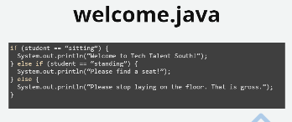

Who has never seen a Java program before?

Volunteer to tell me what this program does?

Java isn’t so scary

3

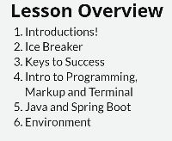

4



5



Mindset-

Break big opportunities, problems or obstacles into small manageable chunks.

Time

Find hour or half hour daily

Ownership

Seems you are already doing that

Pair programming

Tough with Covid

Don’t be afraid to fail

Get out of comfort Zone

Active in Dev community

Meet Ups, coding clubs, learn and network

Always be learning

Angular project using free Movies Restful Service

Release endorphins, basically getting high

6



Show homework and slides in Titus

Some homework done in class, others outside of class

5:00 office hours

7

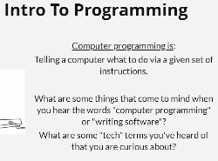

8

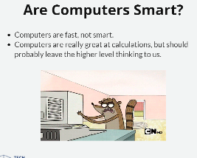

For most development that is true.

What about AI?

[Search](https://en.wikipedia.org/wiki/Watson_(computer)) for watson computer wiki

Google Photos look for fish

9

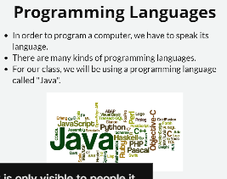

We will also be learning HTML, CSS, Javascript

?? Computer languages over time <https://www.youtube.com/watch?v=Og847HVwRSI>

10

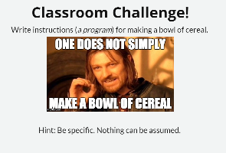

Open notepad

Walking to Walmart

ERROR: I can’t reach cereal

ERROR: broke hand on cupboard door

ERROR: Cereal is not open

ERROR: Cereal is already open

ERROR: Milk all over floor

Happy Path programming

Un-happy path programming

What do you do if you are out of cereal or milk?

What if the dishes are all dirty?

11

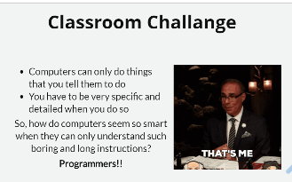

It is your intelligence that makes the program work, not the computer’s

12

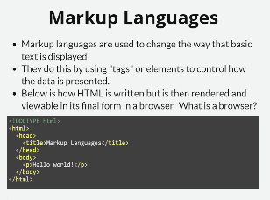

Show file C:\Users\Chuck\OneDrive\TTS\Code Immersion Java\Day 1 - Intro to Programming & Intro to HTML\Intro to programming\ MarkupLanguages.html

In notepad and in chrome

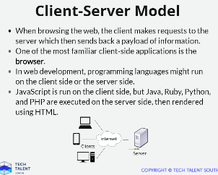

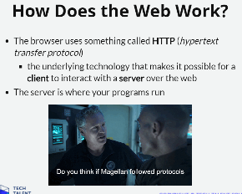

Remember hypertext transfer protocol – interview question

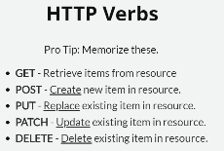

Type in Amazon in browser, which verb we using?

Search for new sweater? Post

Order an item? Post

No use for other 3, remember for interview

16



Not sure about safety

Configuring a web application is complicated, Convention (Spring Boot) is tool that simplifies by making choices most commonly used.

Configuration term means doing everything from scratch

Buying a cake mix vs. making a cake from scratch

17

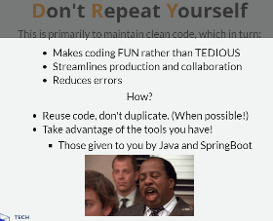

Reusing code is key to writing good code - Object Oriented programming fundamentally allows you to reuse code

* Reuse code that has already been tested, you know it works
* Save time by writing it only once

18

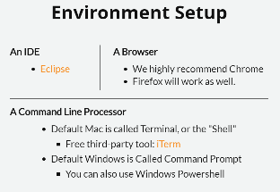

Open Eclipse > Help About Eclipse IDE > look for Eclipse Web tools platform

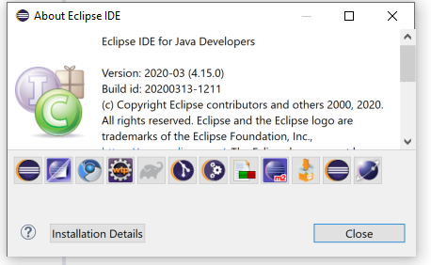

Click create project

General > Project

New > Other > Web > HTML file

Students should have Eclipse. May need to install

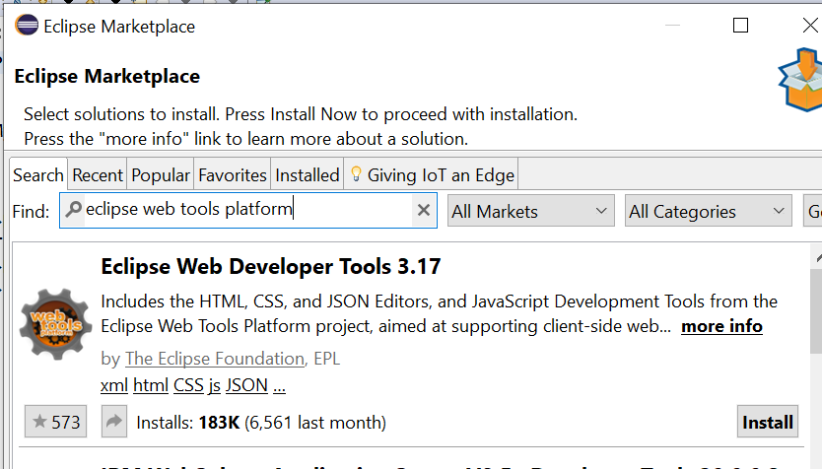

Eclipse (Installed?) *If necessary see Eclipse-install.docx*

Built for Java, works for HTML, Javascript, CSS

Visual Studio is better for web site development (Can look at later if interested)

Most common browsers in business

<https://en.wikipedia.org/wiki/Usage_share_of_web_browsers>

Chrome has best tools for web developers

Open <https://www.techtalentsouth.com/> F12, right click inspect button, change text

IE is dead, unsupported shortly

Run Command from Windows Search

* Old school programming, useful to know still today

19

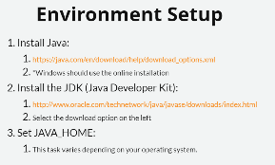

Do I need to install Eclipse? Do before Java

Open and walk through ***Java-Install.docx***

20

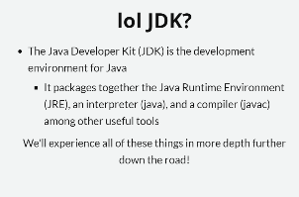

21

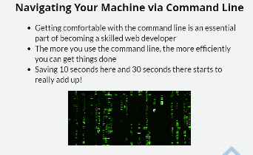

In Windows development, not so much, may be more true in Unix world

Still important skill, most operations can be done with File Explorer

22 - 23

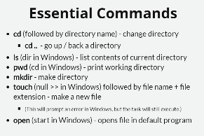

Open Command window to follow along

Show students command window and File Explorer at same time, step through each option from the slides

Show c: cd.. cd\

C:\TTS>Md my_project

C:\TTS>cd my_project

C:\TTS\my_project>null >> x.txt

'null' is not recognized as an internal or external command,

operable program or batch file.

C:\TTS\my_project>start x.txt

C:\TTS\my_project>md text_files

C:\TTS\my_project>md images

C:\TTS\my_project>mv x.txt text_files

'mv' is not recognized as an internal or external command,

operable program or batch file.

C:\TTS\my_project>move x.txt text_files

1 file(s) moved.

C:\TTS\my_project>copy x.txt text_files

1 file(s) copied.

C:\TTS\my_project>del x.txt

Activity for Windows

Cd\

Dir

Mkdir goodlion badlion

Dir

Cd goodlion

Null >> simba.html

Null >> Mufasa.html

Null >> scar.jpg

